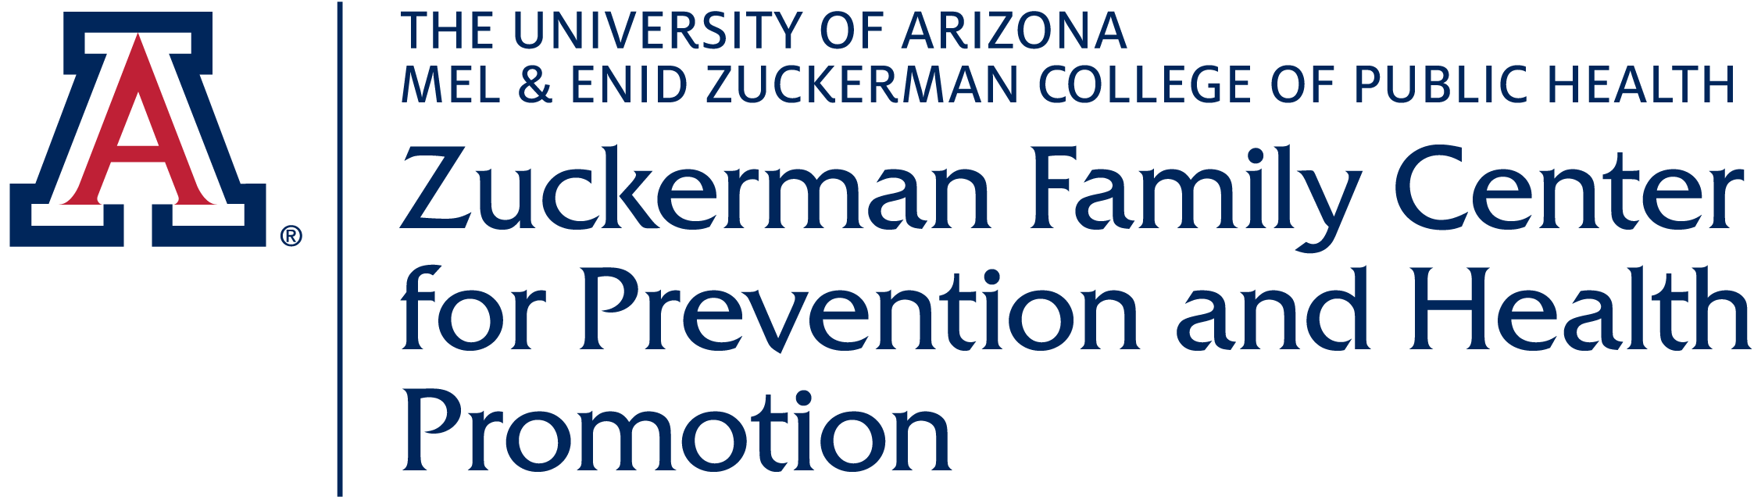

Organization Name:

Healthy 2B Me Summer Camp

Zuckerman Family Center for Prevention & Health Promotion

Organization Background:
Our Center Mission is to help impact and improve the health and wellbeing of the Tucson community through outreach, education, training and research. The goal of our summer camp is to educate and empower elementary school aged children with positive wellness knowledge & messaging

Internship Project Title
Camp Counselors

Project Description:
We have offered our unique summer camp since 2013 reaching over 500 under-served children in southern AZ. During the pandemic, we were able to continue camp as a remote learning experience for families. You can find more information on our website: zfcphp.arizona.edu.

We are looking for enthusiastic undergraduate students who enjoy sharing their knowledge and working with children. The prospective individuals must be able to commit to the Monday-Friday schedule in June & July 2024 to be available from 8:30-3:30 pm Monday thru Friday weekly to help run camp. Each student intern are given the tools/curriculum needed to assist in daily activities. Join us for a great, interactive internship and highlight YOUR personal knowledge and passion!

Internship project keywords (check all that apply).

☐Health Disparities
☐Public Health Preparedness
☒Collaborations with Community
☒Collaborations with University
☒Community health service
☒Physical Activity
☐Substance Abuse
☒Mental Health
☐Access to care
☒Nutrition
☐Reproductive/Sexual Health
☐Environmental Health
☐Maternal/Infant Health
☒Tobacco Use
☐Injury/Violence Prevention
☐Immunization
☐Infectious Disease
☒Oral Health
☐Evaluation
☐Policy Development
☒Program Planning
☐Data Analysis
☐Other Click or tap here to enter text.

When: When do you want the work done? Check all that apply.
☐Fall Semester
☐Spring Semester
☒Summer Term
☐I want this listing to remain active indefinitely and we will accept applications from students for any upcoming semester.
☐This listing is only for a specific semester/term: _____

Where:
Organization Mailing Address: 3950 S. Country Club, Suite 330 Tucson, AZ 85714

Address where Student will work (if different from above)
We will also be working at several different sites this summer including: a local TUSD K-8 school, a local Boys & Girls Club in South Tucson and the Pascua Yaqui Center

​☐Check here if the student may have the option to work remotely from a site not listed above for all or part of this project.

Student Characteristics:
Students passionate about wellness and working with children ages 7-10. The prospective individual should also be well organized, creative, and enjoy being active. They will be able to deliver parts of the curriculum and adjust topics to their educational passions. Outgoing students that like to have fun!

Level of Expertise Needed:
Undergraduate: The internship for undergraduates will provide an experience that allows students to incorporate classroom learning into wellness practice.

Both experiences prepare students for future employment.
☐MPH
☒Undergraduate
☐Either

Supervision
Nicole Falbo Health Educator
23 years UA employee; 13 years at MEZCoPH; 11 years Lead Camp Coordinator

Compensation/Benefits/Professional Development
-Will be discussed with individual applicants
-Fingerprinting and background checks are mandatory (payment covered by the camp)
-Lunch and snacks are provided daily for campers and camp staff as are resources for working with the camp participants

Please contact Nicole to discuss this amazing internship opportunity and how you can be part of the H2BM Camp tradition at MEZCoPH!

Application Contact Information

Nicole Falbo; nbergier@arizona.edu

Cell: 520-591-3669

Work 520-626-5470

