PERSONAL & FAMILY FINANCIAL PLANNING
Learn more at norton.arizona.edu
Follow us @uaznorton

Advising Syllabus

What is Academic Advising?
Academic advising is a collaborative relationship between a student and an advisor to assist the student in the development of meaningful educational plans and goals that are consistent with personal interests, values, and abilities.

PFFP Advisor Information & Location
Tiffany Ortega
PFFP Majors and Minors
McClelland Park Room 203H
520-621-7138
tortega@email.arizona.edu

Schedule an advising appointment online:
https://norton.arizona.edu/academic-advising/personal-family-financial-planning

Academic Advising & Student Learning Goals:
Consistent academic advising meetings will expose students to important information, resources, and opportunities that will aid student success. Advising within the Norton School of Family and Consumer Sciences is committed to working collaboratively with students as they work toward the following learning goals.
- Students will demonstrate knowledge of university and college academic policies and procedures
- Students will demonstrate knowledge of PFFP academic curriculum, including all requirements needed to graduate according to personal timeline and goals
  - Students will learn the role of their academic advisors in their college education, and will learn how and where to locate their academic advisors when needed
  - Students will learn how to find and utilize their academic advisement report and PFFP catalog checklist, and will construct an academic plan for graduation
  - Students will learn how to navigate university websites in order to find policy information regarding dates and deadlines, withdrawing from courses, financial aid and tuition, and academic requirements
- Students will demonstrate increased responsibility for making decisions regarding academic, personal, and professional goals
  - Students will learn how to find and utilize university resources that will support individual needs and promote academic success
  - Students will learn how to seek guidance from faculty and advisors, and will develop connections that support their academic and professional growth
- Students will demonstrate an understanding of career and professional development opportunities
  - Students will learn how to connect with the PFFP internship coordinator and other on-campus career development services
  - Students will critically reflect upon academic and career goals through advising conversations, personal exploration, and participation in extracurricular experiences

Make the Most of Academic Advising: Before, During, and After Your Meeting
Advising Roles and Responsibilities  Student Responsibilities  - Read University Email Daily  - Take the initiative to meet with your advisor at least once per semester, or as often as needed, to discuss your progress  - Be involved in the advising process by being prepared to discuss your goals and educational plans during meetings, bring questions and necessary materials to your meeting, and be open to suggestions  - Take responsibility for making academic and career decisions based on available information and advice  - Develop a working knowledge of policies, procedures, deadlines, and campus resources  - Create an academic plan directed toward completing your degree  - Review and become familiar with your major/minor requirements each semester and track your progress towards graduation  - Utilize UA resources that will help you succeed academically and prepare for life after graduation | Advisor Responsibilities  - Provide accurate and consistent information  - Clarify, interpret, and confirm program requirements, policies, procedures, and deadlines  - Assist students with creating short and long-term academic plans  - Assist students with making academic and career decisions consistent with interests, values, and abilities  - Assist students as they explore opportunities both on and off campus that will support personal and academic goals  - Listen responsively to address questions, concerns, and problems  - Facilitate relationships between students and other individuals on campus; refer students to appropriate support services when needed  - Maintain confidentiality according to the Family Educational Rights and Privacy Act (FERPA)  - Consider student’s best interest when advocating for policy or curricular changes  - Be available and accessible to answer questions
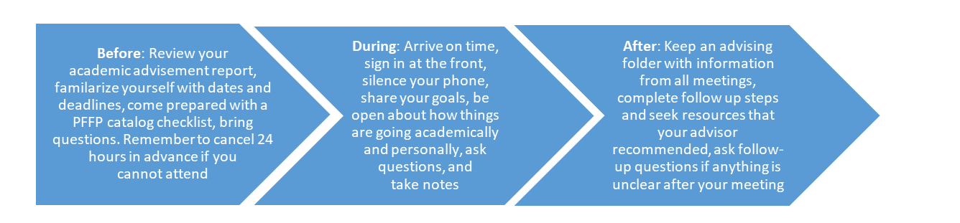

Learn more at norton.arizona.edu
Follow us @uaznorton

Student Resources
Registrar: http://registrar.arizona.edu/  Academic Dates & Deadlines:  https://www.registrar.arizona.edu/dates-and-deadlines  Think Tank: thinktank.arizona.edu  CALS Learning Lab: https://cals.arizona.edu/learning-lab  Writing Skills Improvement Program: http://wsip.arizona.edu/  Study Abroad: https://global.arizona.edu/study-abroad  Campus Health: https://www.health.arizona.edu/  CAPS (Counseling Services):  https://health.arizona.edu/counseling-psych-services  CALS Life Management Counseling:  https://cals.arizona.edu/life-management-services  Scholarships & Financial Aid: https://financialaid.arizona.edu/  Bursar’s Office: http://bursar.arizona.edu/  UA Phonebook: http://directory.arizona.edu/phonebook  UITS (technology services): http://uits.arizona.edu/  UA Libraries: http://new.library.arizona.edu/ | Student Engagement & Career Development: http://career.arizona.edu/  FSHD Internships and Applied Skills: https://norton.arizona.edu/fshd/internships  CALS Career Center:  https://career.cals.arizona.edu/  Dean of Students: https://deanofstudents.arizona.edu/  Cultural & Resource Centers, Other Campus Resources: https://deanofstudents.arizona.edu/support/campus-resources  ASUA: https://asuatoday.arizona.edu/  Disability Resource Center: http://drc.arizona.edu/  THRIVE Center: https://thrive.arizona.edu/  Advising Resource Center: https://advising.arizona.edu  Pre-Health Advising:  https://theacenter.arizona.edu/pre-health/pre-health-professions-advising  Transfer Credit: https://transfercredit.arizona.edu/

For Detailed Information about PFFP Major & Academic Requirements:
View the PFFP Student Handbook, FSHD Checklists, and Sample Graduation Plans online at: https://norton.arizona.edu/pffp-catalog-checklists

Learn more at norton.arizona.edu
Follow us @uaznorton

